**March 31st, 2025**

**Hon. Miss Santia J. O. Bradshaw, M.P.**

Deputy Prime Minister

Minister of Transport and Works

Pine East-West Boulevard

The Pine

**ST. MICHAEL**

Dear Madam,

I have the honour to inform you of the following measures passed at the **100th Sitting** of the Honourable the House of Assembly held on **Monday, March 31st, 2025:**

1. Seaport Industry (Management, Operations and Development) Bill, 2025.
2. A Resolution to grant the sum of $282,421,214 from the Consolidated Fund and to place it at the disposal of the Government to supplement the Estimates 2024-2025 as shown in the Supplementary Estimates No.4 2024-2025.
3. Resolution to grant the sum of $102,816,051 from the Consolidated Fund and to place it at the disposal of the Government to supplement the Estimates 2024-2025 as shown in the Supplementary Estimates No.5 2024-2025.

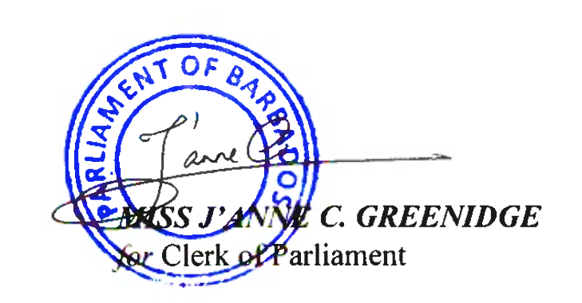Yours faithfully,

**cc. Senator the Hon. Ms. Lisa R. Cummins**

**Minister of Energy and Business**

**Leader of Public Business in the Senate**