**April 23rd, 2025**

**Senator the Hon. Ms. Lisa R. Cummins**

Minister of Energy and Business

Ministry of Energy

Country Road

**ST. MICHAEL**

Dear Madam,

I have the honour to inform you of the following measures passed at the **59th Sitting** of the Honourable the Senate held on **Wednesday, April 23rd, 2025:**

1. Sustainable Fisheries Management and Development Bill, 2025
2. Sustainable Fisheries Management and Development (Seafood Markets and Businesses) Bill, 2025
3. Health Services (Amendment) Bill, 2025.

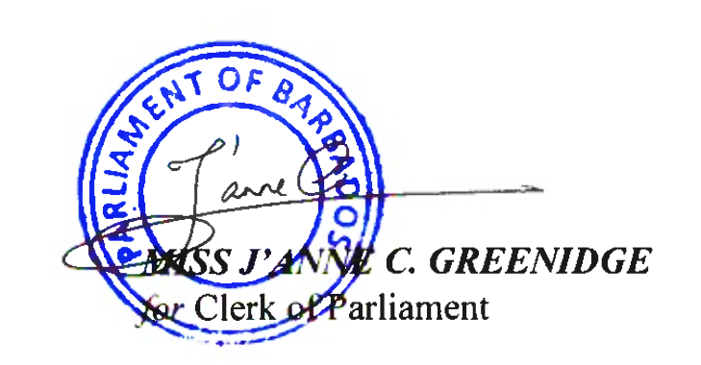Yours faithfully

**cc. Hon. Miss Santia J. O. Bradshaw, M.P.**

**Deputy Prime Minister, Minister of Transport and Works**

**Leader of the House of Assembly**